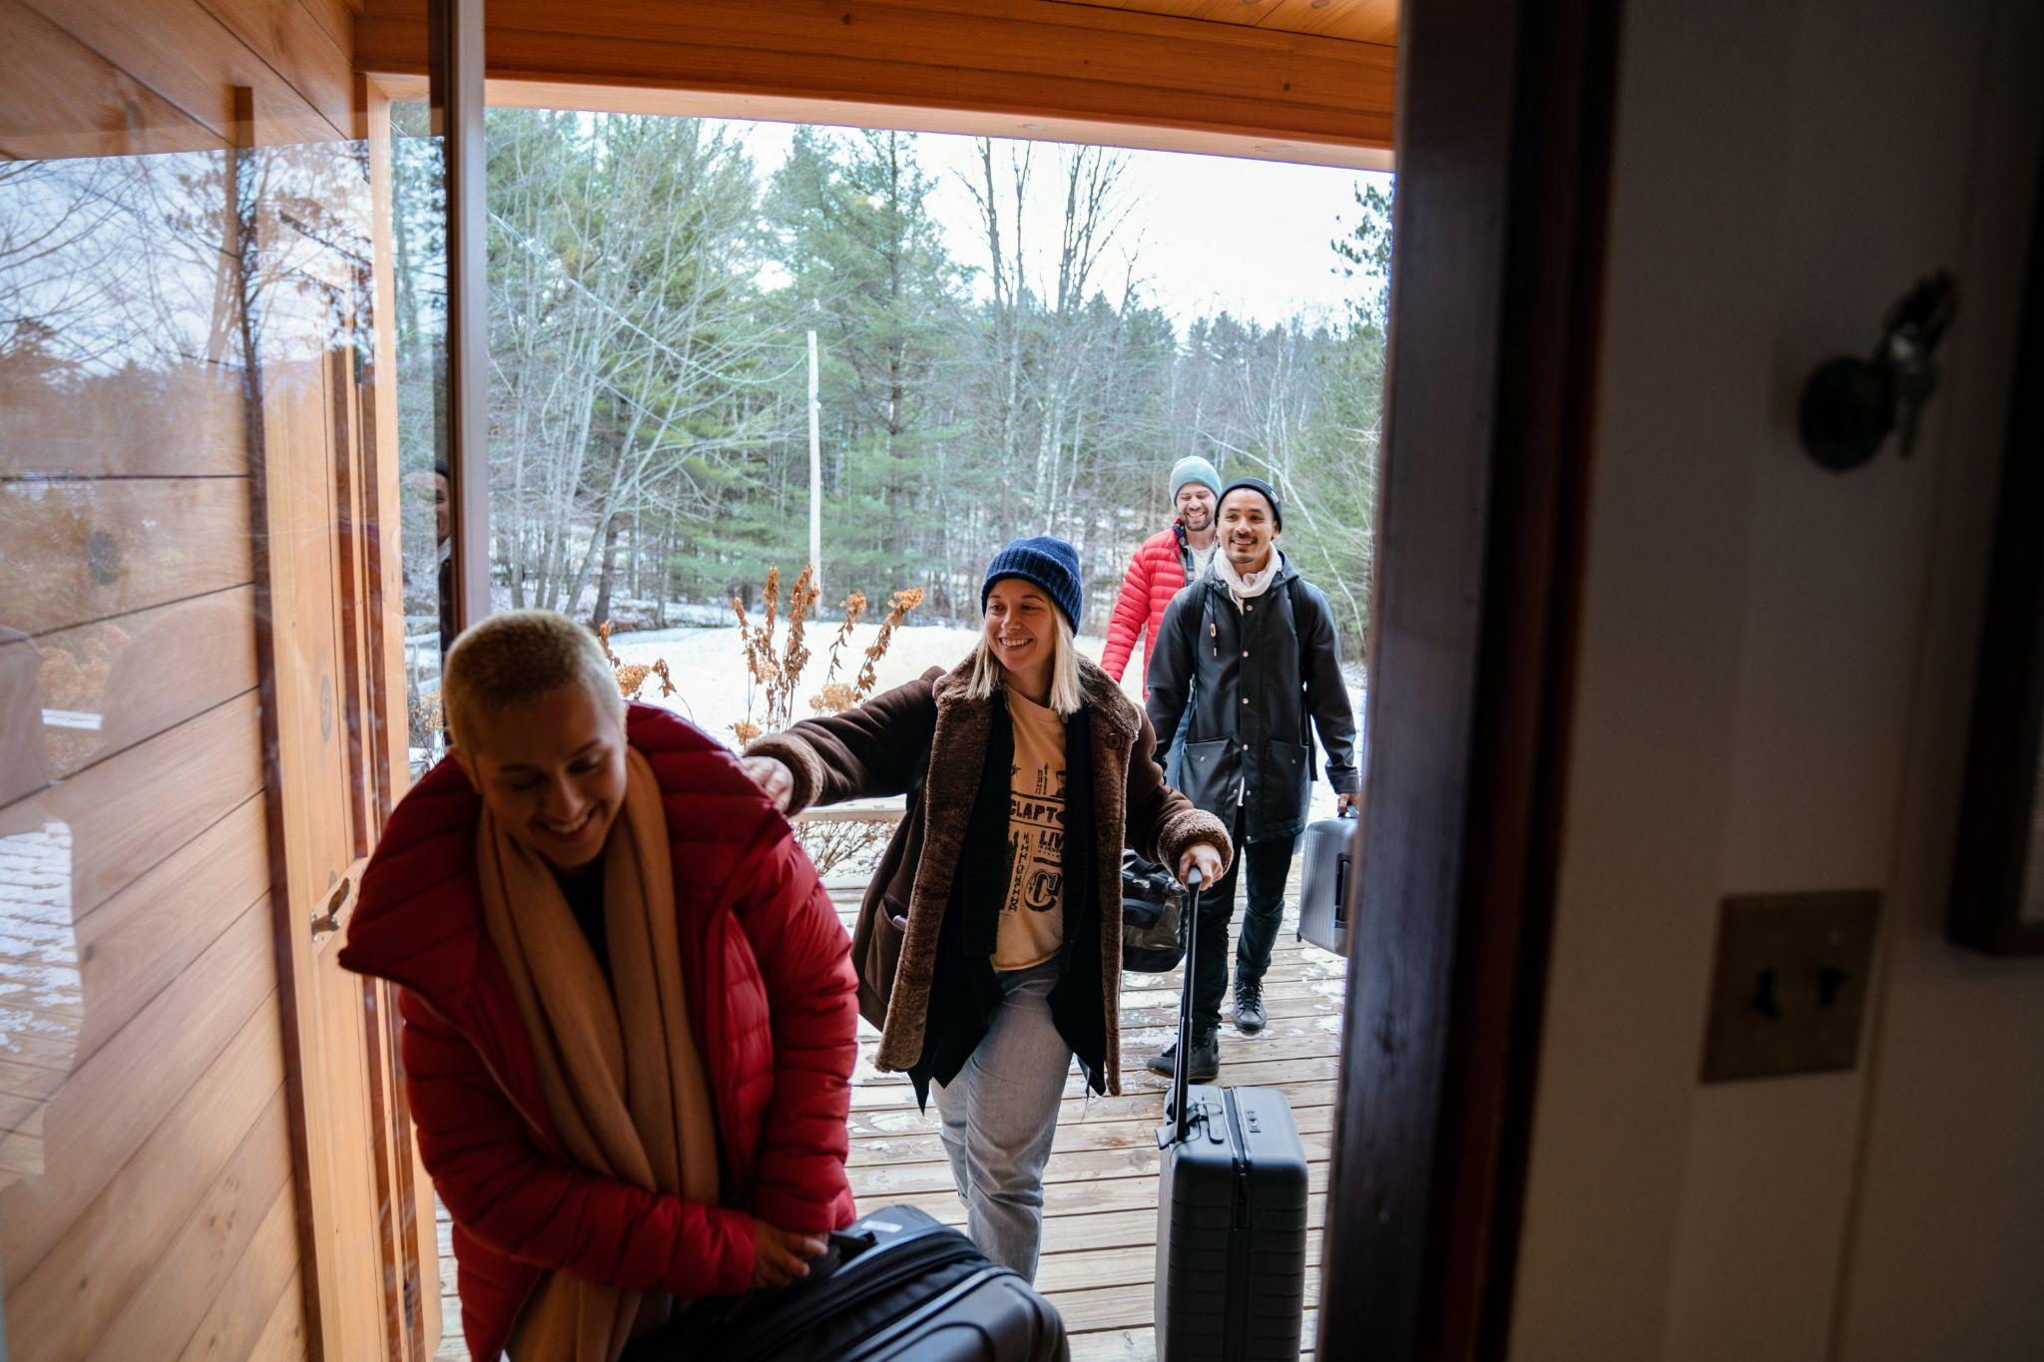

Travel Revolution in Data

The world is undergoing a revolution in how we live and work. Technologies like Zoom make it possible to work from home. Airbnb makes it possible to work from any home. This newfound flexibility is bringing about a revolution in how we travel. The COVID-19 pandemic has suddenly untethered tens of millions of people from the need to work in specific places at specific times. They can now work from anywhere, travel any time, and stay for longer. While technologies like Zoom make it possible to work from home, Airbnb is making it possible to work from any home—and ultimately, to live anywhere.


In recent months, some of the largest companies in the world, including Procter & Gamble, Ford Motor Company, PwC, and Amazon, have announced increased flexibility for employees to work remotely and we expect more companies to follow their lead.

A 7,500-consumer survey we commissioned across five countries found that:
- More than one third (38%) of self-identified hybrid/remote employees say they would rather quit their jobs than go back to work in-person full-time.
- Nearly two thirds (63%) of all respondents say they have come to expect more flexibility from their employers.
- One third say that after the pandemic, they will live somewhere else while working remotely more often than before the crisis.
- Majorities of respondents say they will be doing more travel in the following ways: during off-peak times (55%) and days (53%), over long weekends (55%), and in the spur of the moment (53%).
- More than one third (37%) say they will undertake more long-stay travel.


The Travel Revolution on Airbnb
The ways guests are using our platform show that:

People increasingly are living on Airbnb:
- From July to September, 20 percent of our nights booked were for stays of one month or longer. Guests this year are spending more on these longer stays now than at any point in Airbnb history.
- In 200 destinations around the world, people already are living on Airbnb:
  - 30 percent of guest nights in these places have been for long-term stays.
  - In a dozen-plus destinations, at least 50 percent of recent nights were for long-term stays. These include Bangkok and Phuket, Buenos Aires, San Francisco and Arlington, Virginia.
  - In New York and Los Angeles, almost half of recent nights were for long-term stays.
- In the past year, more than 100,000 guests have stayed continuously on Airbnb for at least three months. About half of these 100,000 guests moved from one listing to at least one other during their travels.
- Older adults aged 60-90, i.e., adults who are most likely to have retired, are using long-term stays on Airbnb more than any other age group.

People are traveling at any time:
- Nearly half (45%) of nights booked on Airbnb were for at least one week, compared to 38 percent two years ago.
- Families are traveling during the week. Globally, they’re showing the most growth in stays on Monday and Tuesday nights.
- In the US, longer weekend stays of three or four days grew by one third over the same time in 2019.



They want amenities for living, not just visiting:
Travelers are seeking out wifi and workspaces, in keeping with the shift toward remote work, along with kitchens, in keeping with living anywhere. But one must-have comfort of home stands above the rest: Everyone wants to bring their pet along. Globally, the most searched-for amenities in recent months were: 1) pets-allowed, 2) pools, 3) wifi, 4) kitchens and 5) free parking.
- In 2019, the top five were: 1) pools, 2) wifi, 3) kitchens, 4) air conditioning, and 5) pets-allowed.
- Searches that filtered for listings allowing pets increased by 55 percent.
- Searches filtering for listings with wifi, kitchens and pets nearly doubled (up 95 percent).

Among longer-stay travelers, the biggest shifts in sought-after amenities have been the increased importance of pets and wifi. Globally, the top searched-for amenities for long-term stay bookers in recent months were: 1) wifi, 2) pets-allowed, 3) kitchens and 4) washer/dryers.
- For the same period in 2019, the favored amenities were 1) kitchens, 2) wifi, 3) air conditioning, 4) washer/dryers, and 5) pets-allowed.
- Long-term stay searches for listings allowing pets more than doubled (up 128%).
- Long-term stay searches for listings with laptop-friendly workspaces increased by 73 percent.
- Long-term stay searches for listings with wifi and pets increased by 270 percent.



The Current State of Travel
Along with the above trends in how people want to travel, an analysis of our recent data also reveals trends in where people are traveling:

Border reopenings reveal pent-up demand:
As countries around the world start to loosen their travel restrictions, we’ve been seeing sudden increases in interest in these countries. For example, in the US, which historically is the largest inbound travel market in the world:
- During the week following the October 15 announcement of the November 8 reopening date, nights booked by foreign guests for stays starting November 8 increased by 44 percent.
- As of this week, starting on November 8, Hosts in more than 4,000 different destinations across the US will welcome inbound foreign guests.
- Among these destinations, the five most popular destinations are Los Angeles, Miami, New York, Orlando and the South Florida Atlantic Coast.
- Among all the places these guests are traveling from, the top-five source cities are London, Paris, Santiago, Toronto and Vancouver.

After so much time spent apart from loved ones due to lockdowns and travel restrictions, we’re also seeing greater interest in holiday travel over 2019:
- As of the end of September, we had over 40 percent more nights booked for Thanksgiving week in the US than at the same time in 2019.

We’re seeing this strong demand extend into 2022:
- Long-term stays are our fastest-growing trip length and family trips are our fastest-growing trip type based on bookings for 2022 as of September 30, 2021.
- In our 7,500-sample, five-country survey, interest in travel overall is high, with more than two thirds (71 percent) saying they are currently booking or considering travel within the next year.

Cross-border travel is recovering:
Even before the latest announcements about lifted border restrictions, we were seeing recovery in both longer-distance and cross-border travel:
- Across all possible trip lengths, between early 2021 and now, the most acceleration in growth for guests has been for trips of more than 3,000 miles from home.
- Overall, cross-border travel has been increasing steadily throughout the year, from 20 percent of gross nights booked in the first quarter, to 27 percent in the second, to 33 percent in the third.
- For October 2021, cross-border travel gross nights booked hit approximately 80 percent of levels from October 2019.
- Even with most international travel having been shut down during much of the pandemic, connection between people of different backgrounds on Airbnb and the desire to travel across borders never went away. Since the start of the pandemic, Hosts and guests have communicated about bookings in over 1,700 pairs of languages.

Forward-Looking Statements

This press release contains forward-looking statements within the meaning of the “safe harbor” provisions of the Private Securities Litigation Reform Act of 1995 about us and our industry that involve substantial risks and uncertainties. In some cases, forward-looking statements can be identified by terms such as “may,” “will,” “appears,” “should,” “expects,” “plans,” “anticipates,” “could,” “outlook,” “intends,” “target,” “projects,” “contemplates,” “believes,” “estimates,” “predicts,” “potential,” or “continue,” or the negative of these words or other similar terms or expressions that concern our expectations, strategy, plans, or intentions. All statements other than statements of historical facts contained in this press release, including but not limited to statements regarding the expected policies of companies and expectations of people with respect to working remotely, expectations regarding travel trends; the travel behavior of guests; the potential impact of the lifting of travel restrictions, the impact of border re-openings for travel on our overall business and our Hosts, the origin and destinations of inbound travelers to the United States, the demand for travel; and cross-border travel trends, are forward-looking statements. Although we believe that the expectations reflected in these forward-looking statements are reasonable, we cannot provide any assurance that these expectations will prove to be correct.

The following factors are among those that may cause actual results to differ materially from the forward-looking statements:
- the effects of the COVID-19 pandemic on our business, the travel industry, and travel trends;
- changes in policies and regulations regarding inbound travel across countries; and
- future changes or disruptions in the travel and hospitality industries or economic downturns and the other factors discussed under “Risk Factors,” “Management’s Discussion and Analysis of Financial Condition and Results of Operations,” and “Cautionary Note on Forward-Looking Statements” in our Annual Report on Form 10-K filed with the U.S. Securities and Exchange Commission (the “SEC”) on February 26, 2021 and any subsequent Quarterly Reports on Form 10-Q filed with the SEC.

Any forward-looking statements speak only as of the date of this press release and reflect our beliefs and opinions as of the date of this press release. We expressly disclaim any obligation to update or revise any information contained in this press release, except as required by law.

Clearpath Strategies survey of 7,500 adults across Australia, France, Mexico, the UK and the US; September 20-26, 2021; margin of error +/-1.13.
All data in this post is for Q3 2021, and all comparisons are to Q3 2019, unless otherwise specified.
As of November 1, 2021 for all stays booked on or after October 15, 2021, with a check-in on and after November 8, 2021

